Que 1
Show Databases:
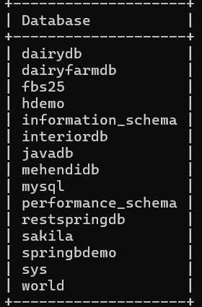

Que 2
Countries Table
mysql> create table countries
-> (country_id int(11), country_name varchar(20),
-> region_id int(11));
ERROR 1046 (3D000): No database selected
mysql> use fbs25;
Database changed
mysql> create table countries
-> (country_id int(11), country_name varchar(20),
-> region_id int(11));
Query OK, 0 rows affected, 2 warnings (0.06 sec)

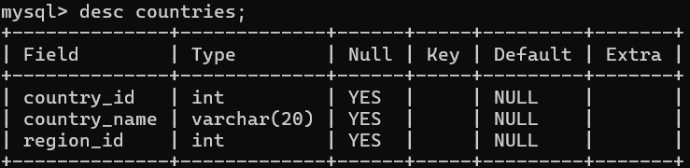

Que 3
Jobs Table
mysql> create table jobs
-> (job_id int primary key,
-> job_title varchar(20) not null,
-> min_salary double(7,2),
-> max_salary double check(max_salary>=25000));
Query OK, 0 rows affected, 1 warning (0.03 sec)

mysql> desc jobs;
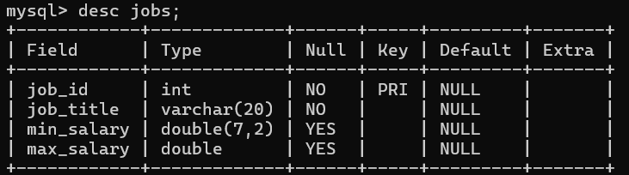
Que 4
Job_History Table
mysql> create table job_history
-> (employee_id int,
-> start_Date date, end_date date,job_id int,
-> department_id int);
Query OK, 0 rows affected (0.03 sec)

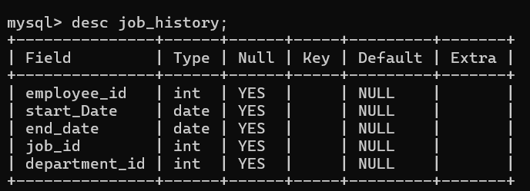
Que 5
Countries Table
mysql> alter table countries
-> ADD CONSTRAINT unique_country_id UNIQUE (country_id);
Query OK, 0 rows affected (0.04 sec)

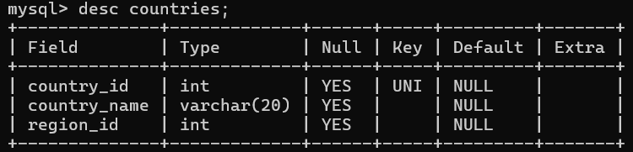

Que 6
Jobss Table
mysql> CREATE TABLE jobss (
-> job_id INT,
-> job_title VARCHAR(20) DEFAULT '',
-> min_salary INT DEFAULT 8000,
-> max_salary INT DEFAULT NULL
-> );
Query OK, 0 rows affected (0.02 sec)

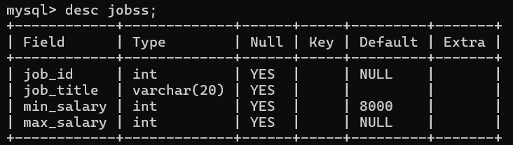

Que 7
Department Table
mysql> create table department
-> (DEPARTMENT_ID decimal(4,0),
-> DEPARTMENT_NAME varchar(30) not null,
-> MANAGER_ID decimal(6,0) ,
-> LOCATION_ID decimal(4,0),
-> primary key (DEPARTMENT_ID, MANAGER_ID));
Query OK, 0 rows affected (0.02 sec)

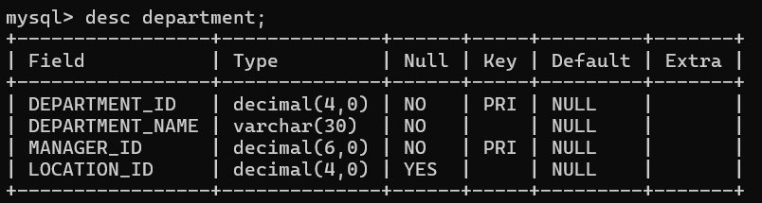

8 que
Department Table
mysql> create table departments
-> (department_id int,
-> manager_id int,
-> dept_name varchar(50),
-> primary key(department_id, manager_id));
Query OK, 0 rows affected (0.02 sec)

Employee Table
mysql> CREATE TABLE employees (
-> employee_id INT PRIMARY KEY,
-> first_name VARCHAR(50),
-> last_name VARCHAR(50),
-> email VARCHAR(100),
-> phone_number VARCHAR(20),
-> hire_date DATE,
-> job_id INT,
-> salary DECIMAL(10, 2),
-> commission DECIMAL(5, 2),
-> manager_id INT,
-> department_id INT,
-> FOREIGN KEY (department_id, manager_id)
-> REFERENCES departments(department_id, manager_id) );
Query OK, 0 rows affected (0.03 sec)
